FRUIT AND ITS COLOR USING BACKTRACKING
Aim
To write a Prolog program to identify the color of a fruit using facts, rules, and backtracking.
Objective
· To understand the basic concepts of Prolog.
· To represent fruits and their colors using facts.
· To use rules for querying fruit colors.
· To understand how Prolog uses backtracking to find multiple solutions.
Algorithm
1. Start the program.
2. Define facts representing fruits and their colors.
3. Define a rule fruit_color/2 to find the color of a given fruit.
4. Enter a query with a fruit name.
5. Prolog searches the facts from top to bottom.
6. If a matching fact is found, Prolog returns the corresponding color.
7. If the user requests another solution using ;, Prolog performs backtracking and searches for another matching fact.
8. Display the result.
9. Stop.
Flowchart 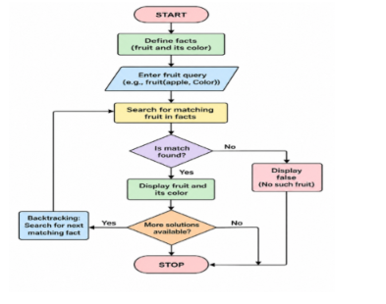
Prolog Code
% Facts: fruit and its color
fruit_color(apple, red).
fruit_color(apple, green).
fruit_color(banana, yellow).
fruit_color(orange, orange).
fruit_color(grape, purple).
fruit_color(grape, green).
fruit_color(mango, yellow).
fruit_color(mango, green).
Output:
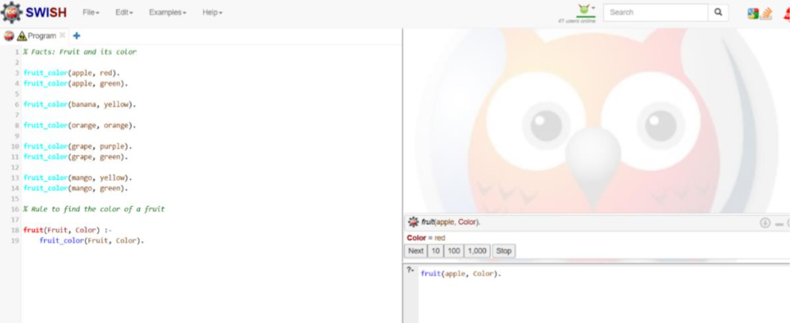
Result
Thus, the Prolog program to identify the color of a fruit using backtracking was successfully implemented and executed. Prolog returns the possible colors one by one, demonstrating the concept of backtracking.

